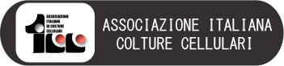

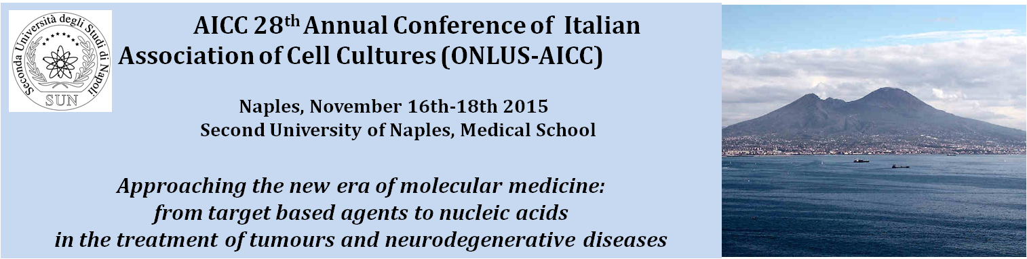

AICC
Italian Association of Cell Culture

The AICC was founded in Bologna in 1980 as an Italian wing of the "European Tissue Culture Society" (ETCS) in order to promote the study and application of in vitro culture for the development of biomedical research through scientific meetings, publications, training in vitro culture techniques, exchange of information between researchers and research institutes. The AICC currently has about 150 members from the most important Italian Universities and Research Institutes.

AICC annual meeting

Every year the AICC organizes an annual congress open to members but also to researchers, especially younger, who wish to attend the sessions of speakers selected among outstanding Italian and international scientists. In addition to the plenary session, it is always present a poster session reserved to younger researchers who wish to share and discuss their data with more experienced ones. In order to stimulate scientific research every year several prizes for the best posters are awarded.

2015 XXVII Annual Meeting

The annual congress on 2015 will be held in Naples in the historical buildings of the School of Medicine of the Second University of Naples which features prestigious halls in the palace that belonged to Joachim Murat and in the Complex of S. Andrea delle Dame. The halls of the School of Medicine of the SUN are seventeenth-century buildings that have been hosting the SUN Medical School University from the end of the nineteenth century. Today they are equipped with the most modern audio / video systems.
The conference is divided into three days that include three plenary session with international speakers, three regular sessions with short oral presentations, a posters sessions, and ancillary course of flow cytometry held by the GIC (Italian Society of Cytometry).

Moreover there will be a social dinner and a guided visit to the unique Anatomical Museum of SUN

Scientific committee: Michele Caraglia, Gianpaolo Papaccio, Fortunato Ciardiello, Salvatore Del Prete, Raffaele Addeo, Antonio Febbraro, Paolo Grieco, Carlo Leonetti, Vincenzo Desiderio, Katia Scotlandi, Elena Capasso, Giuseppe Pirozzi, Stefania Meschini, Massimo Donadelli, Francesca Zazzeroni, Sonia Emanuele

Meeting presidents:
Michele Caraglia, Department of Biophysics Biochemistry and General Pathology, Tel 0815665871 (studio) 0815665874 (Lab) email: michele.caraglia@unina2.it;
Salvatore Del Prete, Chief of the Oncology Unit of the “San Giovanni di Dio” of Frattamaggiore, Naples.

Preliminary program

Day I

November 16 2015

Aula Magna, SUN Medical School
(Via Costantinopoli 104, Naples)

8.30 Registration

9.30 Meeting Opening and Introductive Remarks

Rector of the Second University of Naples
Prof. G. Paolisso

Pro-Rector of the Second University of Naples and advisor of the healthcare division
Prof. G. Nicoletti

AICC President
Dr. Katia Scotlandi

Presentation of the meeting: Prof. Michele Caraglia (SUN and AICC Vice-President), F. Ciardiello (SUN), S. Del Prete (Frattamaggiore Hospital)

Section: Changing the faith of a drug without changing the mechanisms: the nanotechnological approach

Chairs: F. Ciardiello, S. Del Prete

10.00 Lecture: How to define nanotechnology in the medical field: refining and retuning active drugs (Prof. P. Caliceti, University of Padova)

10.30 Nab-paclitaxel and Peg-filgrastim: old and new indications (Prof. P. Tagliaferri, Università “Magna Graecia” di Catanzaro)

11.00 Coffee Break

11.30 Target based therapy in breast cancer
(Dr. R. Addeo, Oncological DH, ASL Na2 Nord)

12.00 Liposomal antracyclins in the treatment of ovarian cancer
(Dr. S. Pignata INT Pascale of Naples)

12.30 Light Lunch

Section: drug delivery in cancer therapy

Chairs: C. Leonetti, D. Ingrosso, A. Febbraro

13.30 New treatment modalities in renal cancer (G. Facchini, INT Pascale)

14.00 New treatment modalities in prostate cancer (Guido Giordano, Ospedale “Fatebenefratelli” of Benevento)

14.30 Medical treatment of hepatocellular carcinoma: what present and what future? (L. Montella, Oncology Division, ASL NA2 Nord)

15.00 Liposomes and nanoparticles delivering zoledronic acid in the treatment of human tumours (Prof. Giuseppe De Rosa, University “Federico II” of Naples)

15.30 miRNA and multiple myeloma: limitations and advantages (Prof. P. Tassone, Università Magna Graecia di Catanzaro)

16.00 miR34a: how to deliver nucleic acids in a tumour (Prof. Michele Caraglia, SUN)

16.30 Discussion

16.45 Guided visit to the Anatomical Museum of the Second University of Naples

Day II

November 17 2015

Bottazzi Hall, SUN Medical School
(Via Costantinopoli 16, Naples)

Section: Target Based agents: from the target expression to the molecular addiction

Chairs: S. Meschini, P. Tagliaferri

9.30 The evolution of medical treatments in the era of target based agents: the example of colon cancer (F. Ciardiello)

10.00 Translational cancer research: from the bench to the bed and reverse (W. El Dairy)

10.30 Mechanisms of resistance to target based agents in non small cell lung cancer (F. Morgillo)

Coffee Break and visit to the posters and stands

11.00 Gerocoversion and gerosuppression: controlling cell proliferation and senescence (M. Blagosklonny)

11.30 Target based therapy… (M. Milella)

12.00 Translational Epigenetics for the Early Detection of High-Risk Prostate Cancer. (A.Perry)

12.30 Selected presentations

13.00 Visit to the posters and stands

13.30 Lunch

14.30 Meeting of the AICC associates and prizes and awards to the best posters

Presentations of the winners

Section: miRNAs, siRNAs and mesenchymal stem cells in the treatment of neurodegenerative diseases

Chairs: P. Grieco, G. Tedeschi

15.00 New insights in the understanding of neurodegenerative diseases by advanced imaging (G. Tedeschi)

15.30 microRNAs in ALS pathogenesis and new therapeutic directions (E. Hornstein)

16.00 Neurodegeneration in multiple sclerosis (W. Bruck)

Coffee Break and visit to the posters and stands

17.30 Selected presentations

Social dinner

Day III

November 18 2015

Bottazzi Room of the School of Medicine (Via Costantinopoli 16 Naples)

Section: miRNAs, siRNAs and other long non coding in the treatment of tumours

Chairs: W. El Dairy, G. Papaccio

9.00 Biogenesis and biological roles of miRNAs in tumours (Manuela Ferracin)

9.30 miRNAs in the nervous system tumors (I. D’Agnano)

10.00 How to detect miRNAs in a cell: from real time PCR to nanostrings (V. Desiderio)

10.30
Coffee Break

11.00 Selected presentations

Lunch and poster and stand view

Concluding remarks and ECM questionnaires

Ancillary course: Theorical and practical approaches to flow Cytometry in cell biology.

Section 1. Flow Cytometry basic concept: from theory to the practice.
V. Desiderio (day II 11.30-13.30)
Section 2. Advanced applications: 2.1 Cell Cycle, Apoptosis. V.Tirino
2.2 Autophagy, senescence and drug uptake. S. Zappavigna (day III 11.00-13.00)
The flow Cytometry course is limited to 15 participants that will be selected on the basis of their CV. The cost of the course will be 100 €.

At the end of the course a questionnaire will be filled and a certification of graduation with final vote will be distributed.

REGISTRATION FEES (VAT INCLUDED)

Full fee: Early registration (until 30th September 2014)

AICC and GIC Member € 150,00
Non-Member € 200,00 (€ 150,00 + € 50,00 mandatory membership fee)
Ph.D. € 120,00 (€ 70,00 + € 50,00 mandatory membership fee)
Student € 50,00

Full fee: Late registration (from 1st October 2014)

AICC, and GIC Member € 200,00
Non-Member € 250,00 (€ 200,00 + € 50,00 mandatory membership fee)
Ph.D. € 170,00 (€ 120,00 + € 50,00 mandatory membership fee)
Student € 80,00

The registration fee includes the following:

Attendance at the 28th Annual Conference of Italian Association of Cell Cultures (ONLUSAICC), conference kit, coffee breaks, lunches, CME credits for the assignees. For the social dinner participation an extra quote of 30,00 € is required and the participants have to express their will at the moment of subscription.

