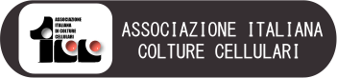

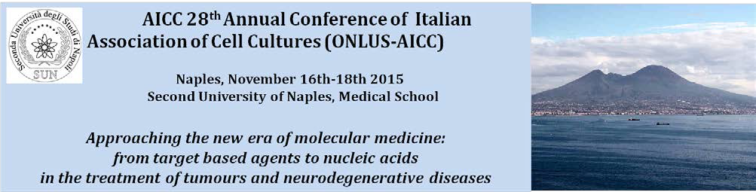

AICC
Italian Association of Cell Culture

The AICC was founded in Bologna in 1980 as an Italian wing of the "European Tissue Culture Society" (ETCS) in order to promote the study and application of in vitro culture for the development of biomedical research through scientific meetings, publications, training in vitro culture techniques, exchange of information between researchers and research institutes. The AICC currently has about 150 members from the most important Italian Universities and Research Institutes.

AICC annual meeting

Every year the AICC organizes an annual congress open to members but also to researchers, especially younger, who wish to attend the sessions of speakers selected among outstanding Italian and international scientists. In addition to the plenary session, it is always present a poster session reserved to younger researchers who wish to share and discuss their data with more experienced ones. In order to stimulate scientific research every year several prizes for the best posters are awarded.

2015 XXVII Annual Meeting

The annual congress on 2015 will be held in Naples in the historical buildings of the School of Medicine of the Second University of Naples which features prestigious halls in the palace that belonged to Joachim Murat and in the Complex of S. Andrea delle Dame. The halls of the School of Medicine of the SUN are seventeenth-century buildings that have been hosting the SUN Medical School University from the end of the nineteenth century. Today they are equipped with the most modern audio / video systems.
The conference is divided into three days that include three plenary session with international speakers, three regular sessions with short oral presentations, a posters sessions, and ancillary course of flow cytometry held by the GIC (Italian Society of Cytometry).

Moreover there will be a social dinner and a guided visit to the unique Anatomical Museum of SUN

Scientific committee: Michele Caraglia, Gianpaolo Papaccio, Fortunato Ciardiello, Salvatore Del Prete, Raffaele Addeo, Antonio Febbraro, Paolo Grieco, Carlo Leonetti, Vincenzo Desiderio, Katia Scotlandi, Elena Capasso, Giuseppe Pirozzi, Stefania Meschini, Massimo Donadelli, Francesca Zazzeroni, Sonia Emanuele

Meeting presidents:
Michele Caraglia, Department of Biophysics Biochemistry and General Pathology, Tel 0815665871 (studio) 0815665874 (Lab) email: michele.caraglia@unina2.it;
Salvatore Del Prete, Chief of the Oncology Unit of the “San Giovanni di Dio” of Frattamaggiore, Naples.

Scientific Secretary:
Olga Fiorentino, Marianna Gallo, Angela Lombardi and Teresa De Simone. Email: angelalombardi@hotmail.it and phone: 3335681776

Day I
November 16 2015
Aula Magna, SUN Medical School
(Via Costantinopoli 104, Naples)

8.30 Registration
9.30 Meeting Opening and Introductive Remarks Rector of the Second University of Naples
Prof. G. Paolisso

Pro-Rector of the Second University of Naples and advisor of the healthcare division
Prof. G. Nicoletti

AICC President
Dr. Katia Scotlandi

Presentation of the meeting:
Prof. Michele Caraglia (SUN and AICC Vice- President)
F. Ciardiello (SUN)
S. Del Prete (Frattamaggiore Hospital)

10.15 Opening Lecture Prof. Carlo Croce
The John W. Wolfe Chair in Human Cancer Genetics, The Ohio State University

“Causes and consequences of microRNA dysregulation in cancer”

Section 1: Changing the faith of a drug without changing the mechanisms: the nanotechnological approach

Chairs: F. Ciardiello, S. Del Prete

11.00 Lecture: How to define nanotechnology in the medical field: refining and retuning active drugs (Prof. P. Caliceti, University of Padova)

11.30 Coffee Break

12.00 Eribuline, Nab-paclitaxel and Peg-filgrastim: old and new indications (Prof. P. Tagliaferri, Università “Magna Graecia” di Catanzaro)

12.20 Target based therapy in breast cancer (Dr. R. Addeo, Oncological DH, ASL Na2 Nord)

12.40 Liposomal antracyclins and personalized therapy in the treatment of ovarian cancer (Dr. S. Pignata INT Pascale of Naples)

13.00 Light Lunch

Section 2: drug deliveryand mi-RNAs in cancer therapy

Chairs: C. Leonetti, D. Ingrosso, A. Febbraro

14.00 New treatment modalities in prostate cancer
(Guido Giordano, “Fatebenefratelli” Hospital, Benevento)

14.20 Epi-microRNAs: regulators of regulators in the treatment of multiple myeloma
(N. Amodio, Magna Graecia University, Catanzaro)

14.40 miR34a: how to deliver nucleic acids in a tumour
(M. Caraglia, Second University of Naples)

15.00 Quality of life and supportive therapy in cancer setting (A. Febbraro, Fatebenefratelli Hospital, Benevento)

15.20 Circulating microRNAs in human cancer (M. Ferracin, University of Ferrara)

15.40 miRNAs in the nervous system tumors (I. D’Agnano, ENEA, Rome)

16.00 selected presentations

16.45 Guided visit to the Anatomical Museum of the Second University of Naples

Day II

November 17 2015
Bottazzi Hall, SUN Medical School
(Via Costantinopoli 16, Naples)

Section 3: Joined session (GIC-AICC)
Target Based agents: from the target expression to the molecular addiction

Chairs: S. Meschini, P. Tagliaferri

9.00 The evolution of medical treatments in the era of target based agents: the example of colon cancer (F. Ciardiello, Second University of Naples)

9.20 Mechanisms of resistance to target based agents in non small cell lung cancer (F. Morgillo, Second University of Naples)

9.40 Multi-target therapeutic approaches for the treatment of Neuroblastoma.
(M. Ponzoni, Gaslini Hospital, Genova, Italy)

10.10 Coffee Break and visit to the posters and stands

10.30 Translational development of rational combinations of targeted agents with synergistic anti-tumor activity. (M. Milella, Regina Elena Institute of Rome)

10.50 Translational Epigenetics for the Early Detection of High-Risk Prostate Cancer. (A. Perry, Trinity College, Dublin)

11.10 The role of autophagy in head and neck cancer treatment: from drug resistance to cell death. (V. Desiderio, Second University of Naples)

11.30 Selected presentations

12.00 Meeting of the AICC associates. Awards to the best posters
13.00 Lunch

Section 4: molecular insight in the treatment of neurodegenerative diseases. mi-RNAs, si-RNAs and advanced imaging.

Chairs: P. Grieco, G. Tedeschi

14.00 New insights in the understanding of neurodegenerative diseases by advanced imaging (G. Tedeschi, Second University of Naples)

14.20 microRNAs in ALS pathogenesis and new therapeutic directions
(E. Hornstein, Weizmann Institute of Science, Rehovot, Israel)

14.40 Neurodegeneration in multiple sclerosis
(W. Bruck, Gottingen University, Germany)

15.00 Coffee Break and visit to the posters and stands
16.00 Selected presentations
Concluding remarks and ECM questionnaires

Social dinner

Day III
November 18 2015

Ancillary course: Theorical and practical approaches to flow Cytometry in cell biology (in cooperation with GIC).

9.30-13.00

Session 1.
1.1 Flow Cytometry basic concept: from theory to the practice. V. Desiderio
1.2 Flow Cytometry and onco-haematology disease. L. Del Vecchio
1.3 Flow Cytometry and Cell sorting of Circulating Tumour cells and Endothelial cells G. Pirozzi

Session 2.
2.1 Cell Cycle, Apoptosis. V.Tirino
2.2 Autophagy, senescence and drug uptake. S. Zappavigna

The flow Cytometry course is limited to 15 participants that will be selected on the basis of their CV. The cost of the course will be 100 €.

At the end of the course a questionnaire will be filled and a certification of graduation with final vote will be distributed.

REGISTRATION FEES (VAT INCLUDED)

Full fee: Early registration (until 30th September 2015)

AICC and GIC Member € 150,00
Non-Member € 200,00 (€ 150,00 + € 50,00 mandatory membership fee) Ph.D. € 120,00 (€ 70,00 + € 50,00 mandatory membership fee)
Student € 50,00

Full fee: Late registration (from 1st October 2015)

AICC, and GIC Member € 200,00
Non-Member € 250,00 (€ 200,00 + € 50,00 mandatory membership fee) Ph.D. € 170,00 (€ 120,00 + € 50,00 mandatory membership fee) Student € 80,00

The registration fee includes the following:

Attendance at the 28th Annual Conference of Italian Association of Cell Cultures (ONLUSAICC), conference kit, coffee breaks, lunches, CME credits for the assignees. For the social dinner participation an extra quote of 30,00 € is required and the participants have to express their will at the moment of subscription.

