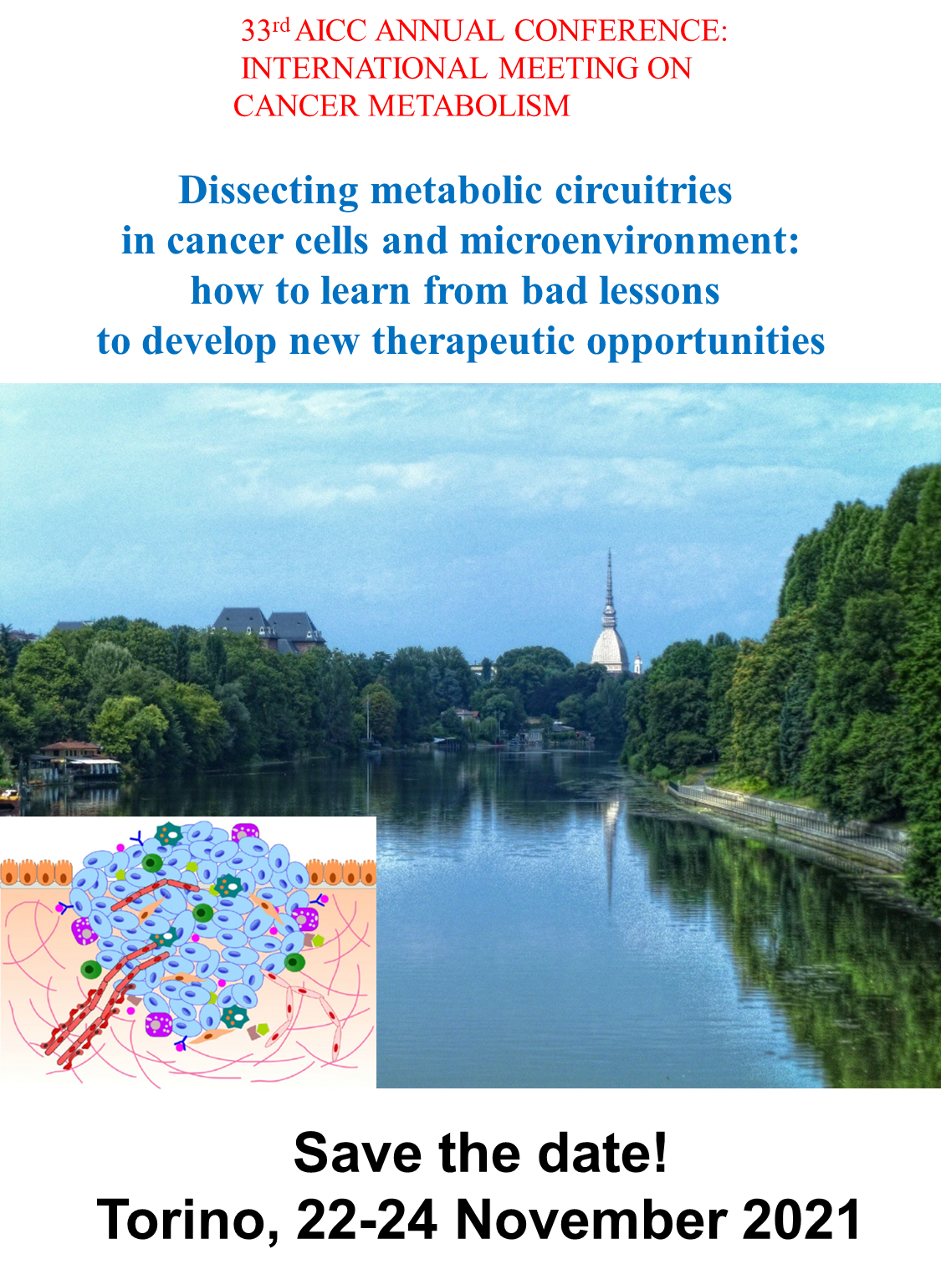
Hybrid meeting
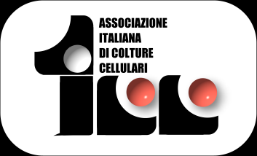
33rd AICC ANNUAL CONFERENCE: INTERNATIONAL MEETING ON
CANCER METABOLISM
Dissecting metabolic circuitries in cancer cells and microenvironment:
how to learn from bad lessons to develop new therapeutic opportunities

The tumor cell and its microenvironment, including the stroma, the vascular component and the immune infiltrate, are linked by multiple cross talks that allow the adaptation of the cancer cells to unfavorable conditions, such as hypoxia, nutrient deprivation, cytotoxicity induced by radiotherapy and chemotherapy, host's immune system recognition.
In this meeting, internationally recognized speakers will discuss the complexity of the metabolic changes that occur during tumor transformation, progression, and acquisition of resistance to therapy. The metabolic circuits established between the tumor cell and the microenvironment, leading to the selection of more aggressive and resistant clones, will be dissected and analyzed, with the final goal to identify new predictive and prognostic biomarkers for patient’s stratification and new therapeutic targets.
Recently, genomics, transcriptomics and proteomics have significantly improved the diagnostic accuracy and the therapeutic approach to the oncological patients, increasingly leading to personalized diagnoses and treatments. The metabolomics is an indispensable complement to the other "omic" techniques, if integrated with “omic” and single-cell imaging, flow-cytometry or molecular-biology-based assays, currently used at preclinical and clinical levels.
In the era of high-throughput techniques at the service of biomedical research and precision medicine, great importance will be given to the most innovative technologies that allow the metabolic mapping of each cancer and/or the generation of in vitro metabolic “avatars” of the individual patient, to make the stratification procedure and the efficacy of therapeutic treatment more and more accurate. The most relevant brands in the field will be present at the meeting, illustrating the latest innovations in a dedicated technical session.
We believe that the meeting will be highly attractive for a broad spectrum of scientists, working in basic and translational research, as well as in clinic units. Besides the presence of world-class speakers, the AICC meeting continues its long tradition of involving your researchers, dedicating slots for oral communications and posters. The best works presented by young scientists will be awarded by special prizes.

Looking for meeting you,

Prof. Michele Caraglia Prof. Chiara Riganti
AICC President AICC Board member
Meeting Organizer

Confirmed speakers:
Patrizia Agostinis, UCL Louvain, Louvain, Belgium
Fatima Baltazar, University do Minho, Porto, Portugal
Luca Cardone, CNR/IRCCS Istituto Regina Elena, Roma
Daria Capece, Universotà de L’Aquila
Alessandro Carrer, Veneto Institute of Molecular Medicine (VIMM), Padova
Ferdinando Chiaradonna, Università degli Studi di Milano Bicocca, Milano
Paola Chiarugi, Università degli Studi di Firenze
Cyril Corbet, UCL Brussels, Belgium
Giannino Del Sal, IFO/Università degli Studi di Trieste
Franca Esposito, Università Federico II, Napoli
Christian Frezza, MRC/University of Cambridge, UK
Giuseppe Gasparre, Università degli Studi di Bologna
Eyal Gottlieb, Technion University, Haifa, Israel
Emilio Hirsch, Università degli Studi di Torino
Massimiliano Mazzone, UCL Louvain, Louvain, Belgium, and Università degli Studi di Torino
Anna Maria Porcelli, Università degli Studi di Bologna
Claudia Piccoli, Università degli Studi di Foggia
Nadia Raffaelli, Università Politecnica delle Marche
Sara Sdelci, Centre for Genomic Regulation, Barcelona, Spain
Carlos Sebastian, University of Barcelona, Spain
Tiziano Serra, AO Foundation, Davos, Switzerland
Antonio Sica, Fondazione Humanitas, Università degli Studi del Piemonte Orientale
Pierre Sonveaux, UCL Louvain, Louvain, Belgium
Saverio Tardito, Beatson Research Institute, Glasgow, UK

